Ballet Uniform

Pre-School & Primary Ballet, Primary & Grade 1 Modern

- Aqua Skirted Leotard (Roch Valley)

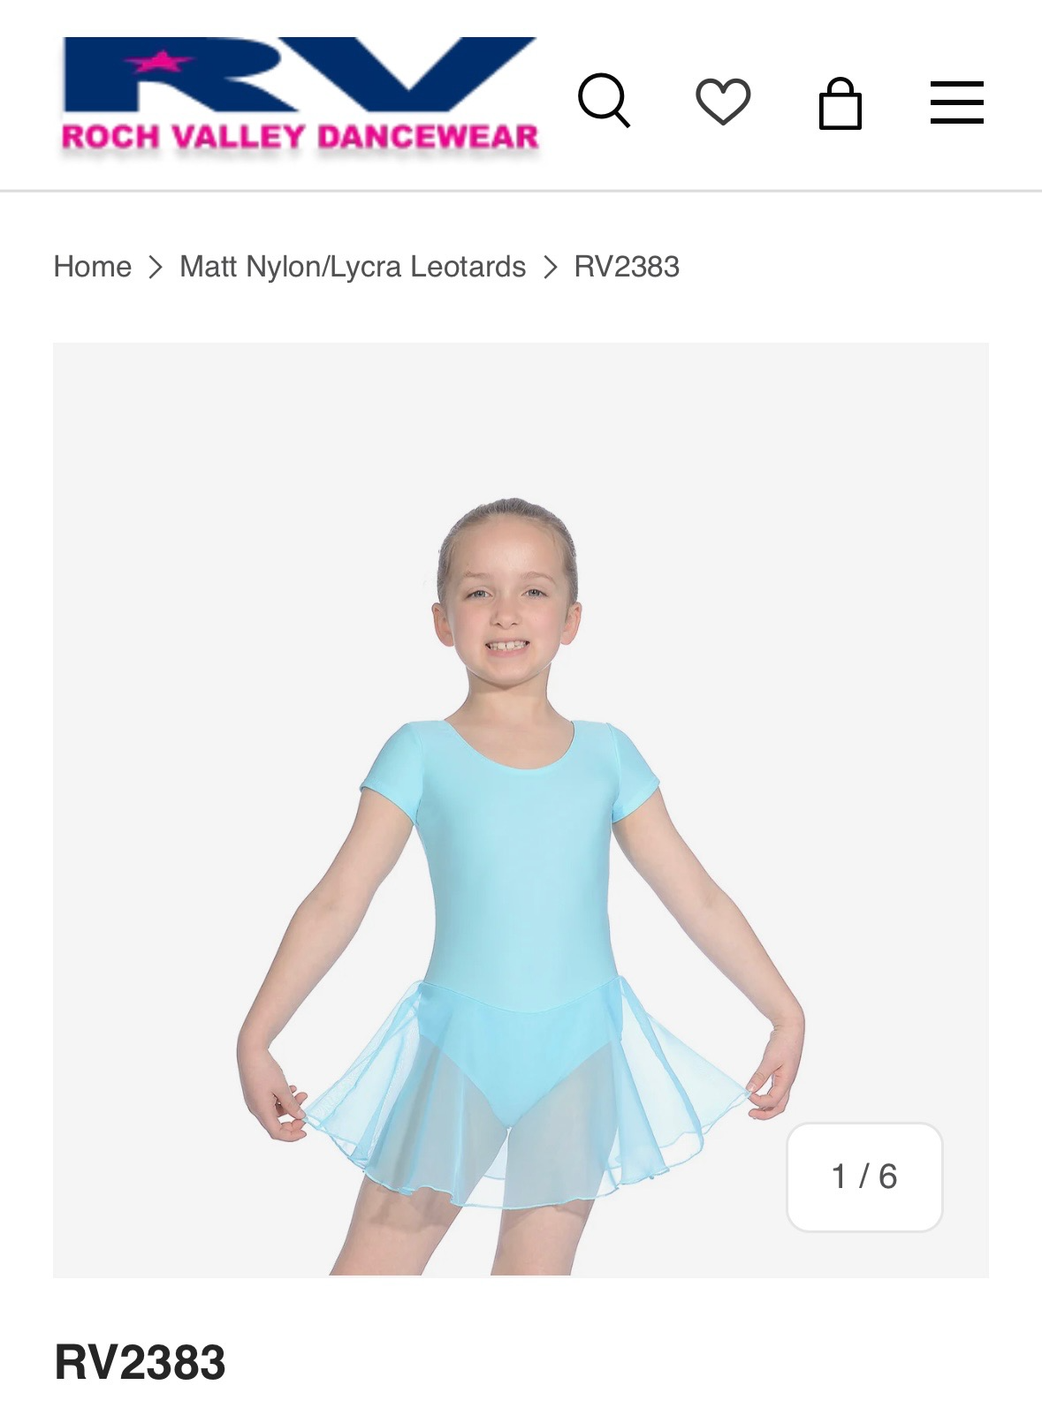

- Pink Ballet Socks/Tights
- Pink Leather Ballet Shoes
- White Velcro Fastening Tap Shoes

Warm-Up Wrap in Aqua – Personalised with Ballaré Logo AND your name! From -AllBoogie.com

Grade 1 & 2 Ballet AND Grade 2 Modern

- Lavender Camisole Leotard (RV)

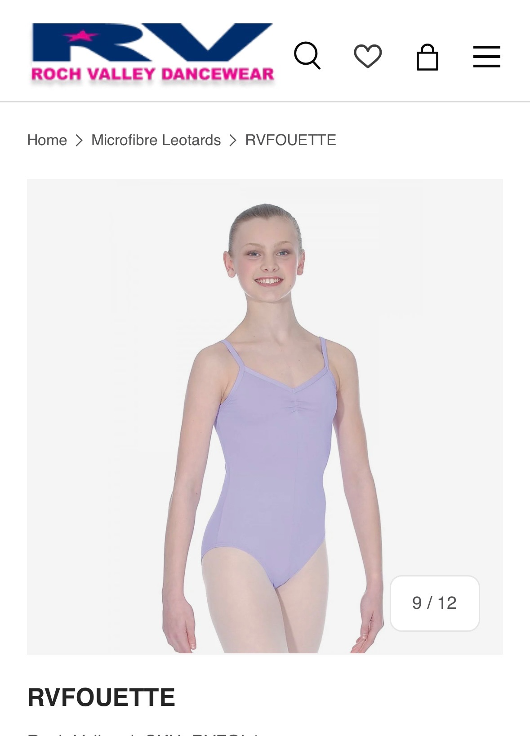
- Pink Ballet Socks/Tights
- Pink Leather Ballet Shoes
- Black Tights for Modern & Tap

Warm-Up Wrap in Lavender – Personalised with Ballaré Logo AND your name! From -AllBoogie.com

Grade 3 & 4 Ballet

- Burgundy Camisole Leotard (RV)

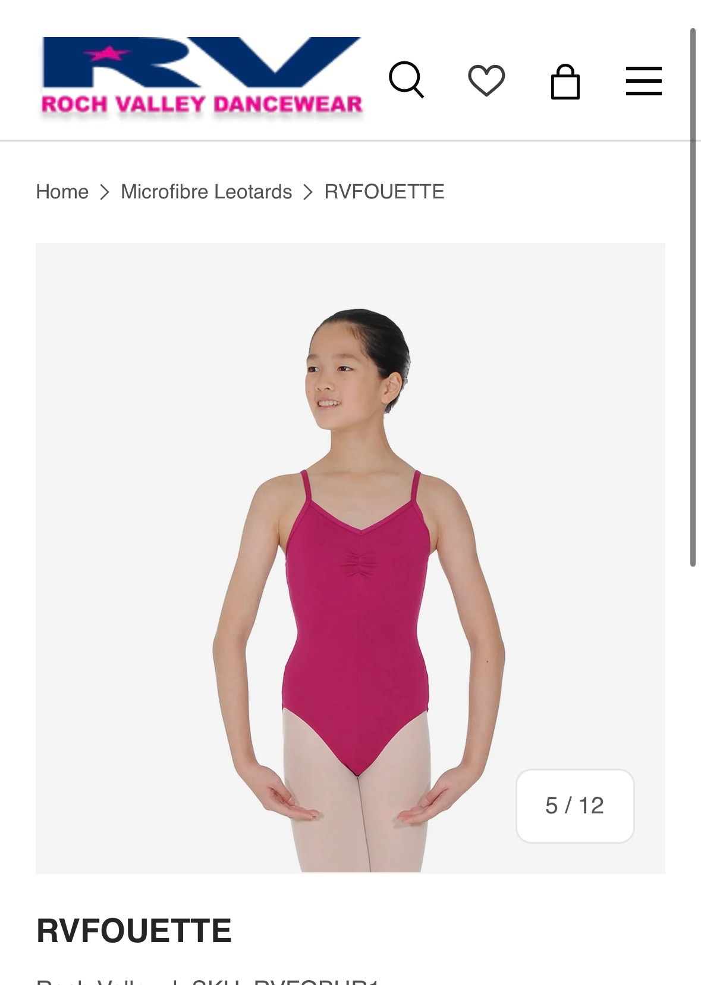

- Pink Ballet Tights
- Pink Canvas Ballet Shoes

Warm-Up Wrap in Mulberry – Personalised with Ballaré Logo AND your name! From -AllBoogie.com

Grade 5 & 6 Ballet

- Navy ‘Elizabeth’ Leotard (RV)

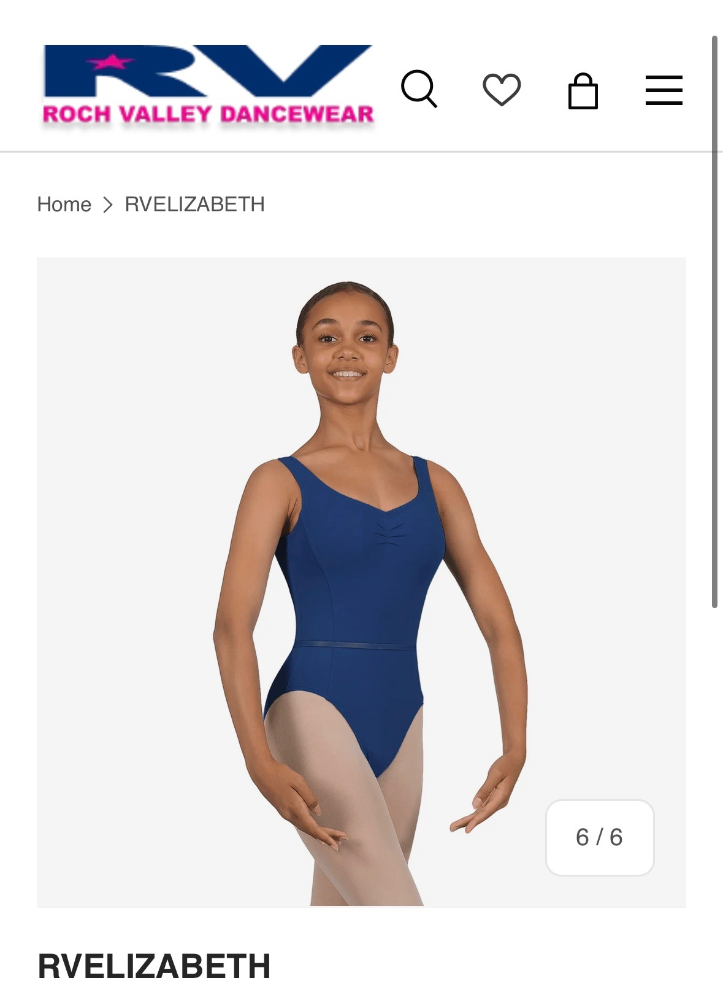

- Pink Ballet Tights
- Pink Canvas Ballet Shoes

Intermediate & Advanced Ballet

- ANY Black Ballet Leotard
- Pink Ballet Tights
- Pink Canvas Ballet Shoes
- Tight Fitting Warm-Up Wear, customised with Ballaré logo AND your name, from AllBoogie.com

Modern & Tap Uniform

Grade 2 Modern

- Lavendar Fouetté Leotard (Roch Valley)

- Black Footless Tights (worn over the top)
- Black Tap Shoes

Warm-Up Top – Personalised with Ballaré Logo AND your name! From - AllBoogie.com

Grade 3 & 4 Modern

- Royal Blue Ariosa Leotard (Roch Valley)

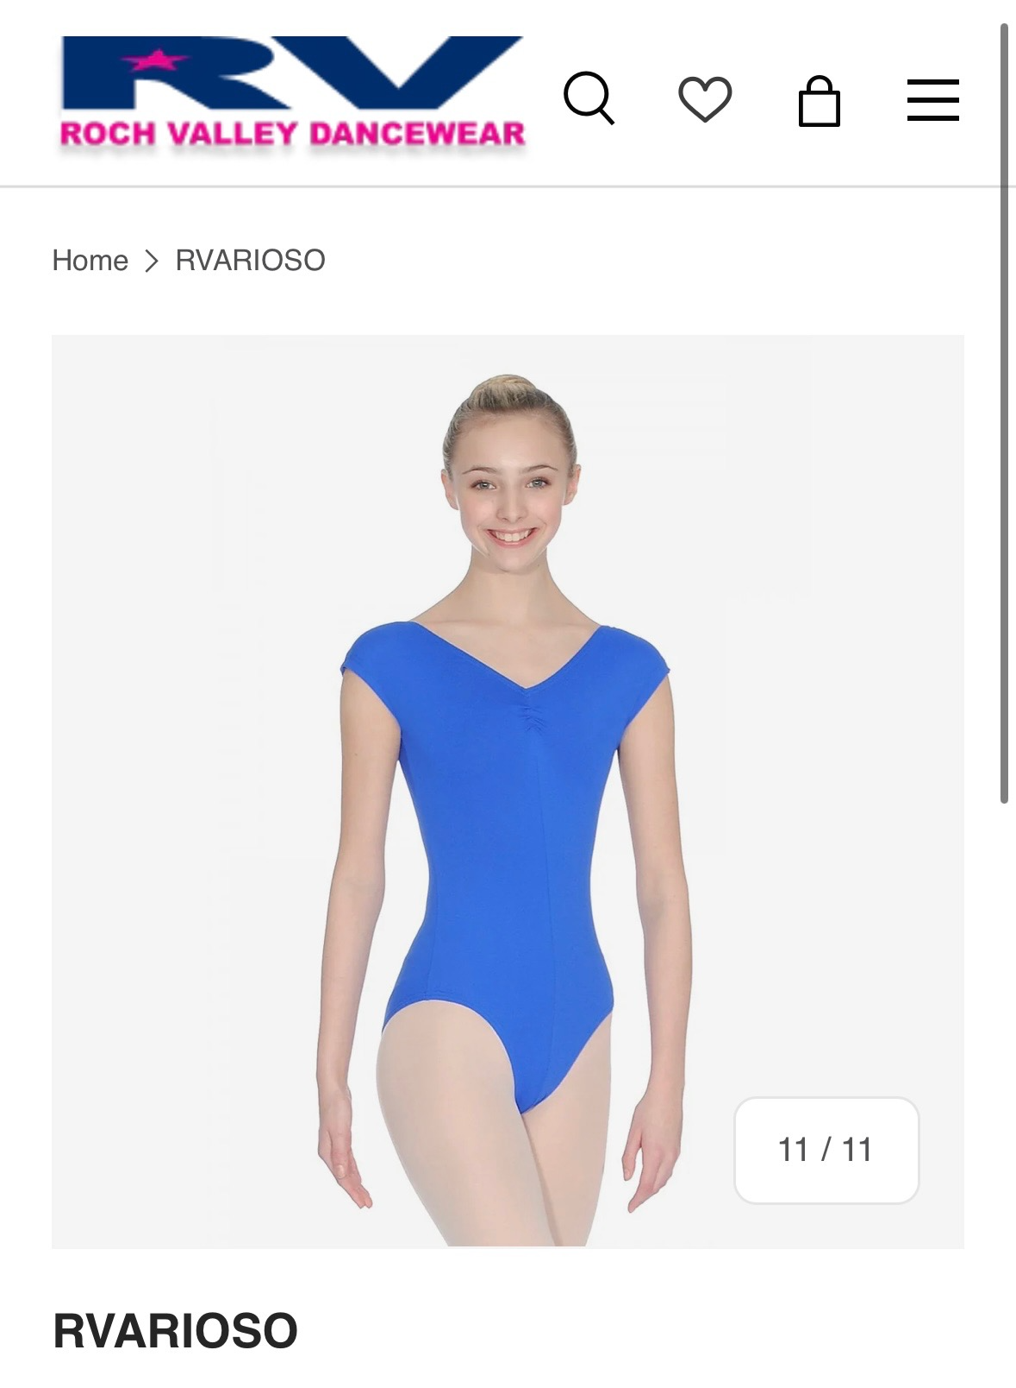

- Black Footless Tights (worn over the top)
- Black Tap Shoes

Warm-Up Top – Personalised with Ballaré Logo AND your name! From - AllBoogie.co

Grade 5 & 6 Modern

- Royal Blue Ariosa Leotard (Roch Valley)

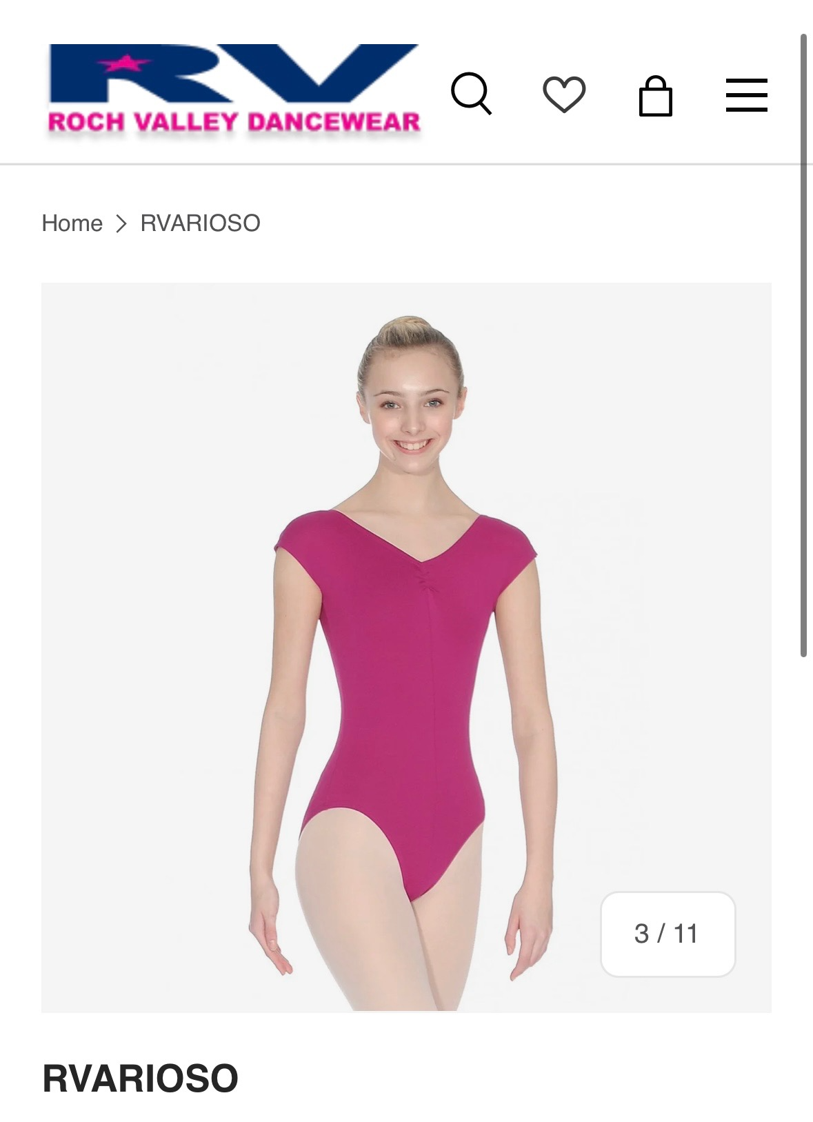

- Black Footless Tights (worn over the top)
- Black Tap Shoes

Warm-Up Top – Personalised with Ballaré Logo AND your name! From - AllBoogie.co

Intermediate & Advanced Modern

- ANY leotard and black tights over the top.
- Tight Fitting Warm-Up Wear, customised with Ballaré logo AND your name, from AllBoogie.com

Jazz Uniform

All Jazz Levels

ANY leotard with black tights or shorts.

(Absolutely no loose trousers or hoodies)

Acro

All Acro Levels

ANY leotard with black tights or shorts.

Contemporary Uniform

All Contemporary Levels

Ballare T-Shirt & Joggers in black/grey – available from All Boogie.

Uniform could be a mix of the Ballaré T-Shirt with plain leggings, or alternatively the Ballaré joggers with a leotard. You don’t have to have both the customised joggers and the t-shirt, just one of them is fine, but students do need to stick to the black/grey uniform code and not wear other colours.

