Ballet Uniform

Pre-School & Primary Ballet, Primary Tap & Modern

- Aqua Skirted Leotard (Roch Valley)

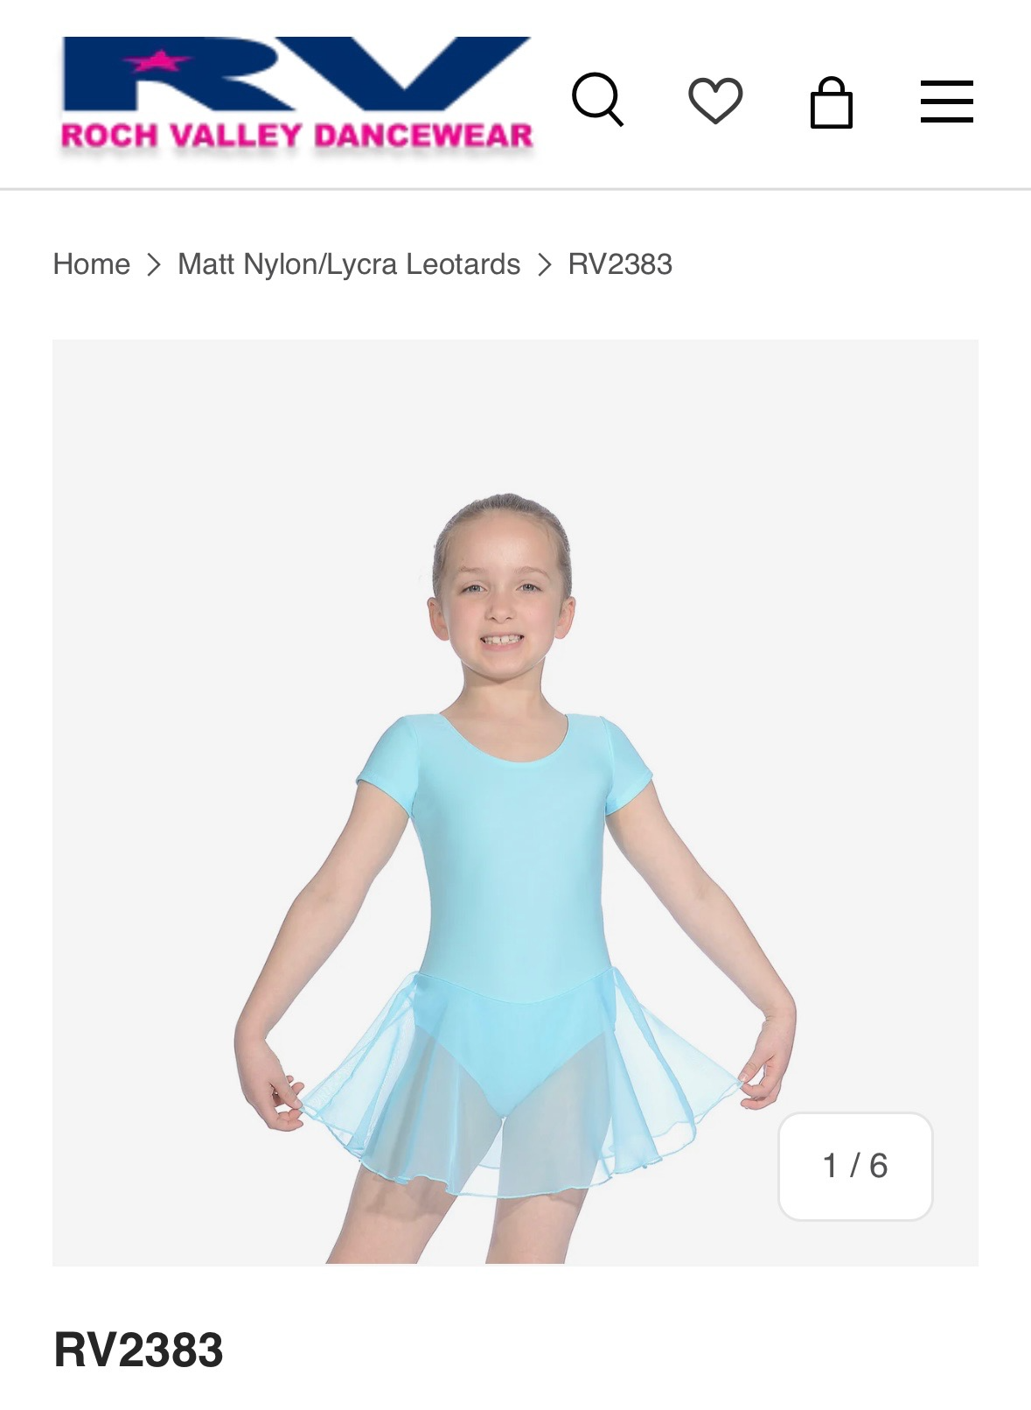

- Pink Ballet Socks/Tights
- Pink Leather Ballet Shoes
- White Velcro Fastening Tap Shoes
(all available at www.ballaredance.co.uk & will come to class)
- Warm-Up Wrap in Aqua – Personalised with Ballaré Logo AND your name!
(available at www.allboogie.com and will be delivered to you at home)

Grade 1 & 2 Ballet AND Grade 1 &2 Tap & Modern

- Lavender Camisole Leotard (RV)

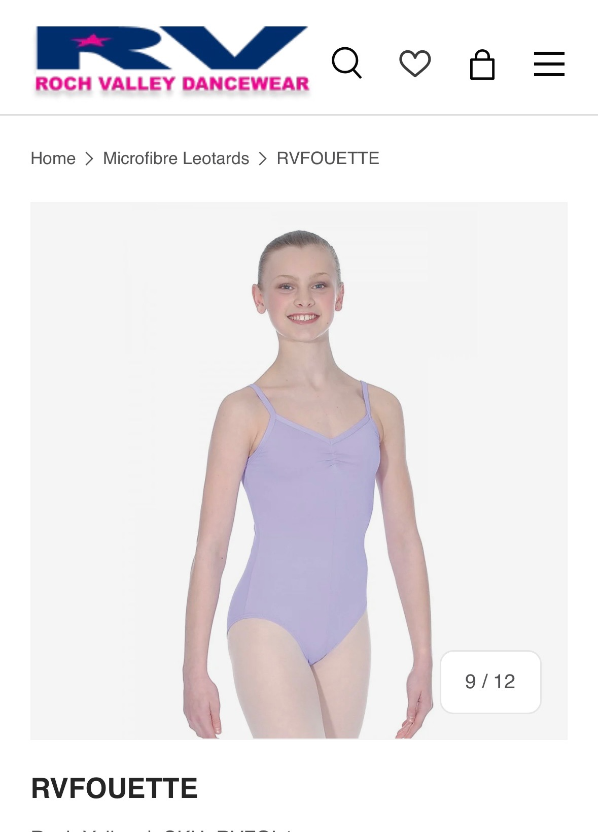

- Pink Ballet Socks/Tights
- Pink Leather Ballet Shoes
- Black Tights for Modern & Tap
(all available at www.ballaredance.co.uk & will come to class)
- Warm-Up Wrap in Lavender – Personalised with Ballaré Logo AND your name!
(available at www.allboogie.com and will be delivered to you at home)

Grade 3 & 4 Ballet

- Burgundy Camisole Leotard (RV)

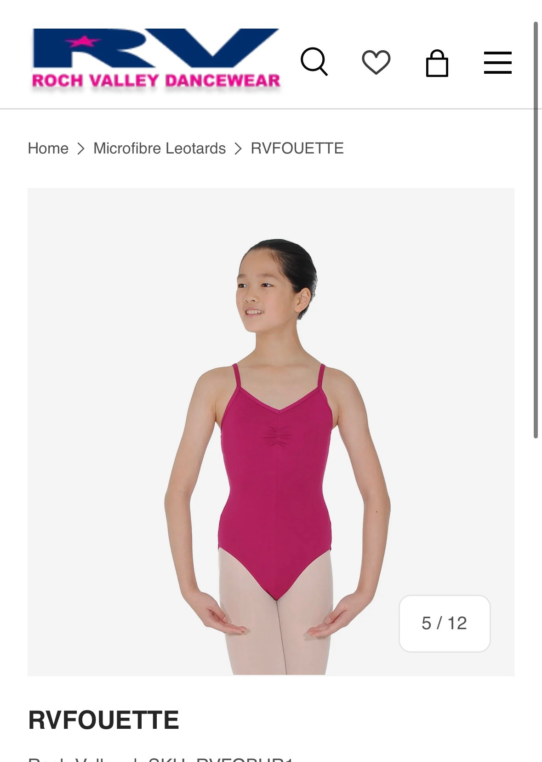

- Pink Ballet Tights
- Pink Canvas Ballet Shoes
(all available at www.ballaredance.co.uk & will come to class)
- Warm-Up Wrap in Mulberry – Personalised with Ballaré Logo AND your name!
(available at www.allboogie.com and will be delivered to you at home)

Grade 5 & 6 Ballet
- Navy ‘Elizabeth’ Leotard (RV)

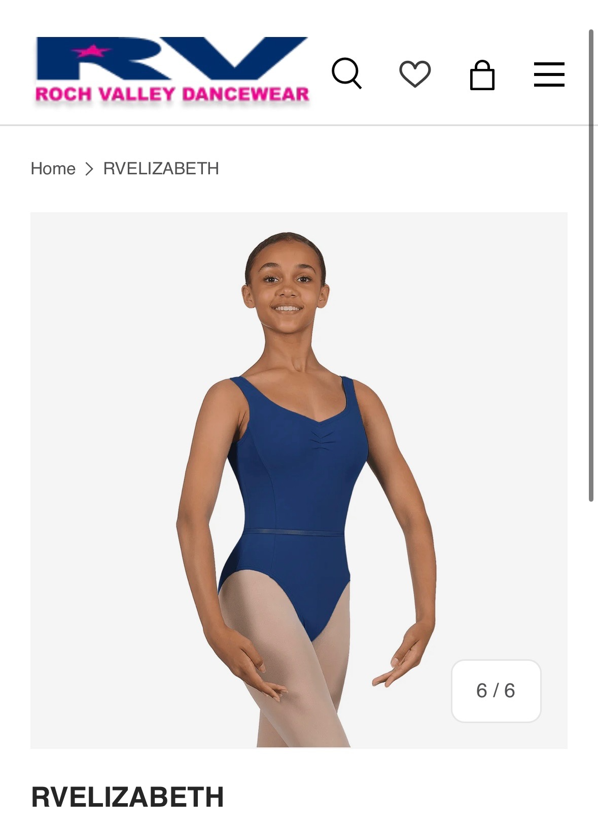

- Pink Ballet Tights
- Pink Canvas Ballet Shoes
Modern & Tap Uniform

Grade 1 & 2 Modern

- Lavendar Fouetté Leotard (Roch Valley)

- Black Footless Tights (worn over the top)
- Black Tap Shoes
(all available at www.ballaredance.co.uk & will come to class)
- Warm-Up Top – Personalised with Ballaré Logo AND your name!
(available at www.allboogie.com and will be delivered to you at home)

Grade 3 & 4 Modern

- Royal Blue Ariosa Leotard (Roch Valley)

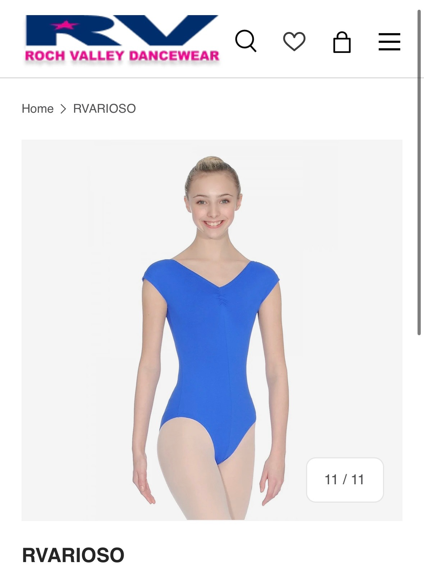

- Black Footless Tights (worn over the top) or black shorts
- Black Tap Shoes
(all available at www.ballaredance.co.uk & will come to class)

Grade 5 & 6 Modern
- Intermezzo Burgundy Leotard

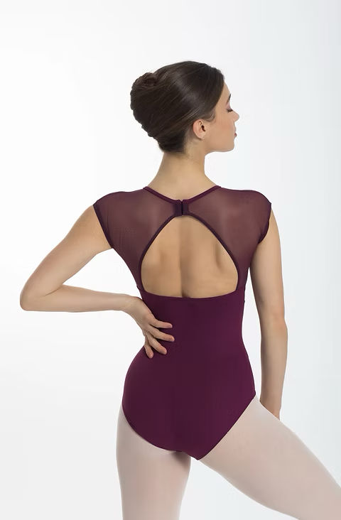

- Black Footless Tights (worn over the top) or black shorts
- Black Tap Shoes
(all available at www.ballaredance.co.uk & will come to class)

Jazz Uniform

All Jazz Levels

ANY leotard with black tights or shorts.

(Absolutely no loose trousers or hoodies)

Acro

All Acro Levels

ANY leotard with black tights or shorts.

Contemporary Uniform

All Contemporary Levels

ANY leotard with black tights or shorts.

OR

Ballare T-Shirt & Joggers in black/grey – available from All Boogie.

Uniform could be a mix of the Ballaré T-Shirt with plain leggings, or alternatively the Ballaré joggers with a leotard. You don’t have to have both the customised joggers and the t-shirt, just one of them is fine, but students do need to stick to the black/grey uniform code and not wear other colours.

Customised Uniform

You can also get Ballaré T-Shirt’s, Hoodies and Onesies to wear to and from class at All Boogie.

Most items can be customised with your child’s name too!

